**Tunable pH-responsive sulfonamide-based polymers via RAFT polymerization**

**as mediators of endosomal siRNA escape**

Cancer is one of the leading causes of death worldwide, claiming nearly 600,000 U.S. lives in 20111. Although chemotherapy effectively kills malignant cells, its indiscriminate toxicity leads to many undesirable side effects. Freeman and Mayhew2 attribute this to the non-specificity of chemotherapeutic drugs, *i.e*., the drugs do not act exclusively on the metabolic pathways of cancer cells. Fortunately, many cancers overexpress certain receptors on their cellular surface, leaving them vulnerable to anti-cancer drug delivery systems functionalized with corresponding targeting molecules3.

Of the major chemotherapeutic methods, RNA silencing by small interfering RNA (siRNA), is emerging as an alternative treatment to traditional chemotherapy4. siRNAs are oligonucleotides capable of silencing specific genes responsible for malignant tumor propagation. Although promising, effective siRNA therapy must overcome the numerous issues associated with drug delivery such as (1) protection of the therapeutic agent, (2) vascular circulation, (3) cellular targeting, (4) cellular internalization, (5) endosomal escape, and (6) siRNA release. Consequently, development of a sophisticated delivery vehicle capable of addressing each of the aforementioned issues is desired. In this regard, the Ringsdorf “depot” model has been the prevailing template for polymeric targeted delivery systems5, but historically it has been difficult to implement as a practical delivery system. Recent developments in polymer synthesis now allow synthesis of well-defined polymers that can act as effective nanocarriers for therapeutic agents. In particular, the development of controlled radical polymerization techniques such as reversible addition-fragmentation chain transfer (RAFT) polymerization has accelerated efforts in targeted delivery by enabling precise control over molecular weight, polydispersity, and copolymerization through mediation by chain transfer agents (CTAs)6. Furthermore, stopping the reaction at moderate conversions can preserve the CTA end moiety. This intermediate, known as a macroCTA, can be isolated and further copolymerized with a different monomer with excellent control over chain extension. The evolution of RAFT and its aqueous counterpart (*a*RAFT) has helped overcome many of the synthetic barriers to implementing the Ringsdorf model, such that it has recently been found to be an effective method for siRNA release7; however, the model itself still has the inherent flaw of lacking a viable endosomal escape mechanism.

To achieve effective *in vivo* targeted delivery, a Ringsdorf-based system would need to include a method of endosomal escape, often referred to as the bottleneck of drug delivery. Of the various escape mechanisms, the most relevant is through physical disruption of the endosomal membrane via hydrophobic polymer-lipid interactions. It has been shown that at endosomal pH (~5), certain pH-responsive peptides become more hydrophobic and can disrupt cellular membranes, allowing penetration of the disrupting species8. However, peptide synthesis is a cumbersome practice that would be difficult to implement on a large scale. The optimal delivery system would thus utilize the dual solubility of amphiphilic peptides to achieve endosomal release, but could be efficiently synthesized on a larger scale.

Conveniently, sulfonamide compounds such as sulfa drugs exhibit desirable pKa values for intra-endosome polymer aggregation, are commercially available at low cost, and have been shown to exhibit pH-dependent solubility when polymerized8. Our group has recently demonstrated the first RAFT polymerization of methacrylamide-containing sulfonamide monomers9, enabling the possibility of utilizing their pH-dependent solubility properties for therapeutic systems. Under acidic conditions, a block copolymer of a given sulfonamide and a hydrophilic monomer should exhibit similar amphiphilicity as the aforementioned peptides, providing a more practical means of facilitating endosomal escape (**Figure 1**).

Drawing upon my previous research in polysulfonamides, I propose to develop a siRNA delivery system providing a sulfonamide block for endosomal escape. My overall research goals are to (1) synthesize a library of polysulfonamides (pSA) encompassing a range of pKa values (**Figure 2**), (2) study the pH-dependent solubility of each polymer, and (3) prepare a block copolymer with pSAs and conduct red blood cell hemolysis assays to measure pH-dependent lipid membrane disruption.

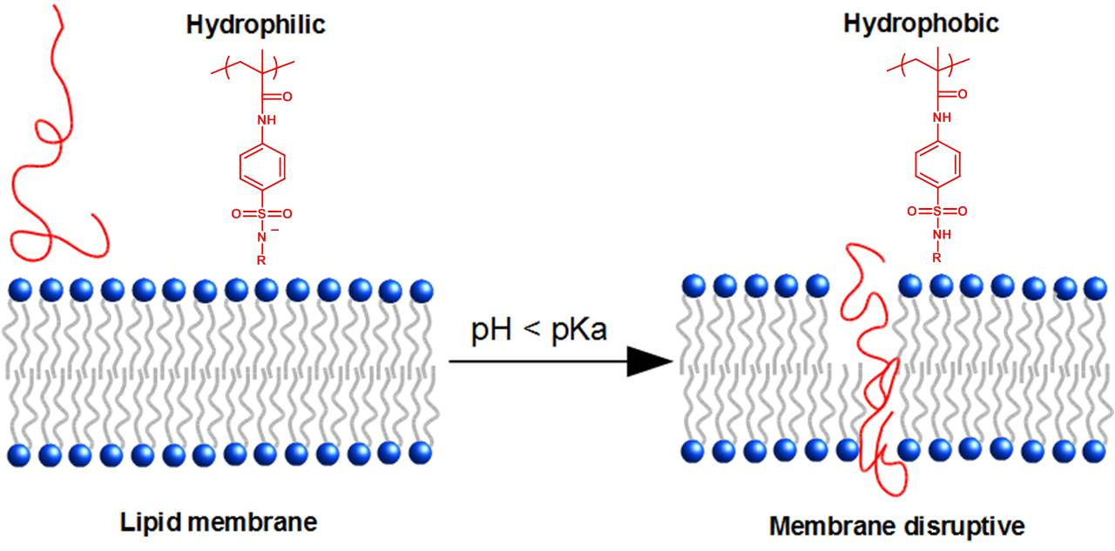I will begin by studying the reaction kinetics of each pSA synthesis. Kinetic studies will elucidate any potential monomer incompatibilities as well as facilitate molecular weight targeting. The polymerizations will then be scaled up and the resultant pSA polymers will be titrated against hydrochloric acid to examine pH-dependent solubility.

**Figure 1.** Endosomal membrane disruption via hydrophobic sulfonamide block

The next step is to incorporate pSAs into a triblock copolymer based on the Ringsdorf depot model10. A statistical copolymer of mSA, *N*-2-hydroxypropylmethacrylamide (HPMA), and *N*-(3-aminopropyl)methacrylamide (APMA) will be prepared as a water-soluble, biocompatible block containing amine reactive functionality for further polymer modification. This polymer will then be functionalized with siRNA and folate targeting groups in preparation for cell studies. Finally, the functionalized polymer will be used in *in vivo* gene knockdown studies to determine therapeutic efficacy.

**Figure 2.** Selected methacryloylsulfonamide monomers (mSA) and corresponding pKa values

In conclusion, I propose to study the efficacy of sulfonamide-containing polymers to facilitate endosomal escape and eventually fulfill the Ringsdorf delivery model. Sulfonamides are readily available, biocompatible, and easily converted into a RAFT-compatible monomers, making them ideal for polymeric delivery systems. By improving the viability of siRNA as a cancer treatment method, development of such a polymeric system may eventually yield a milder and more accessible form of therapy.

**References:**

1. American Cancer Society. Cancer Facts & Figures. Accessed 2011-11-21
2. Freeman, A.; Mayhew, E.; (1986) *Cancer*, *58*, 573-583
3. Smith, D.; Holley, A.C.; McCormick, C.L.; (2011) *Polym. Chem., 2*, 1428-1441
4. Xu, L.; Anchordoquy, T.; (2010) *J. Pharm. Sci.*, *100*, 38-52
5. Ringsdorf, H.; (1975) *J. Polym. Sci. Symp., 51*, 135–153
6. Chiefari, J.: Chong, Y.K.; Ercole, F.; Krstina, J.; Jeffery, J.; Le, T.P.T.; Mayadunne, R.T.A.; Meijs, G.F.; Moad, C.L.; Moad, G.; Rizzardo, E.; Thang, S.H.; (1998) *Macromolecules*, *31*, 5559-5562
7. York, A. W.; Huang, F.; McCormick, C. L.; (2009) *Biomacromolecules, 11*, 505-514
8. Kang, S. I.; Bae, Y. H.; (2005) *J. Control. Release, 80*, 145-155
9. Abel, B.A.; Sims, M.B.; McCormick, C.L. (*manuscript in preparation*)
10. Deshayes, S.; Morris, M. C.; Divita, G.; Heitz, F.; (2005) *Cell. Mol. Life Sci., 62,* 1839-1849